From: https://medium.com/@gippolito-ndp/how-did-the-1-6-rioters-know-to-bring-the-lumber-and-tools-342d6b771063

By: Gippolito Ndp
Date: 20211023
4 min read
How Did the 1/6 Rioters Know to Bring the Lumber and Tools?
Nobody seems to be asking the question, but to me it seems pretty important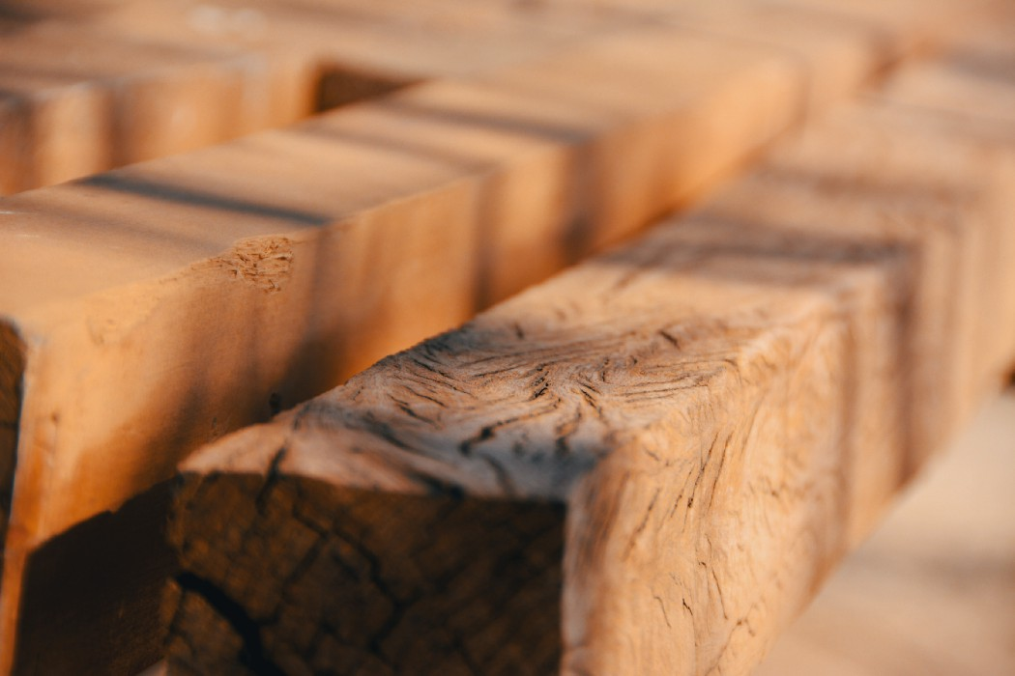
Photo by Facundo Sosa on Unsplash
Remember the gallows erected at the U.S. Capitol on January 6th? There’s a photo of it in this New York Post article with stunning photos of that day — it is the 2nd photo in the piece, and is the best image I could find for the thing.
Forget for a moment whether it is properly constructed, and hefty and stable enough to hang someone from. To me it looks to be about 10 feet tall, and unless someone really faked us out by making balsa wood look like substantial 4 by 4s (at least), the lumber used to make this thing was pretty heavy; and based on sheer size were just not carried around in some guy’s pocket or backpack.
How did whoever brought the wood and tools, and the rope, know to bring them? And (vitally important) when — and from whom — did they find out that Mike Pence was not going to “come through” for them and their fake-tan hero? All the screaming by some portions of the crowd: “Hang Mike Pence! Hang Mike Pence!” Do you remember that? All along that has bothered me, like a marble rattling around in my noggin’ searching for something— but I assumed it was just because of the abhorrent idea of a lynching.
You may also recall, as I do, that on January 6th many people were still speculating whether Pence would — or even could — do anything in his role in the joint session of Congress that day beyond what was constitutionally required. The vast majority of pundits and constitutional scholars I heard or saw that day opined that Pence could do nothing but acknowledge and count the electoral college votes.
But some people had to have known that Pence had decided he did not have the authority or ability to do what he had been asked by Trump to do in Congress on January 6th. And they had to have known it in time to procure or at least bring the wood, rope and tools (and likely some kind of ladder).
The corollary: someone was in touch with someone else, likely well before the Stop the Steal Rally got underway. And here I can remind readers that a criminal conspiracy is just 1) an agreement between two or more persons to commit some crime; and 2) any action by any conspirator in advancing the agreement toward the commission of the crime.
If Trump and those close around him learned on January 5th that Mike Pence had decided the Constitution did not permit him to do anything other than acknowledge and count the elector’s votes at the joint session of Congress on January 6th — if what he actually would do when the moment came was a mystery to most of us — how did the crowd know on January 6th to 1) erect the gallows and 2) go hunting for Mike Pence to hang him high? Who told them, and when?
In the last couple months much more detail has come out about actions by various people beginning in December 2020, and culminating in things that happened on January 5th — and of course on Insurrection Day itself. And now names are being attached with these actions: Steve Bannon, Mark Meadows, and several others. And of course, Donald Trump.
Now we know that on 1/5 Pence had plainly said “No” to Trump. Even while the Stop the Steal Rally was going on before the attack on the Capitol the next day, most everyone else seemed NOT to know what Pence would do. There are few clues to this in the speeches on 1/6, even Trump’s — but he seems to have come to a place in his own mind that he thought Pence would let him down. And that was why the “march on the Capitol” took place.
There remain many questions; but there is a small but growing body of answers. Here’s one answer I now believe is known and very real: only a few people knew before the 1/6 rally that Mike Pence was NOT going to play Trump’s game — and knew it in advance enough to communicate it to others, who then acted (or got others to act) in bringing wood, rope and tools and constructing a gallows — in order to hang Mike Pence!

Conclusion
I still marvel at how 1/6 could have happened in America. But I also still marvel at the capacity of real American patriots, which capacity I believe to be virtually limitless. With my marvel I will also have hope; hope that we can somehow walk back from the brink that some power-greedy haters and dividers have brought us to.
Please take care of yourselves and others, and stay strong and healthy. You are much needed.

